Worksheet: Estimating Planet Parameters

Parameters of the Stellar Event
Time of the peak of the event | = | t₀ | =
Baseline magnitude | = | W149_{base} | =
Change in magnitude (base to peak) | = | 𝛥m_{max} | =
Maximum magnification | = | A_{max} | =
Impact parameter | = | u₀ | =
Change in magnitude for A=1.34 | = | 𝛥m | =
Time at 𝛥m | = | t | =
Einstein Timescale | = | t_{E} = |t₀ - t| | =

Parameters of the Planet
1. Where is the planet?
Time of the planet perturbation | = | t_{planet} | =
Time scaled to the Einstein timescale | = | 𝜏 = |t_{planet} - t₀|/t_{E} | =
Source-lens separation | = | u = √(u₀² + 𝜏²) | =
Position of the images | = | y± = ± (½) ( √(u² + 4) ± u) | =
Is it a major or a minor image perturbation?
Planet-star separation | = | s | =
 |  | log (s) | =

Angle between trajectory and binary axis | = | 𝛂 = atan( u₀ / 𝞃 ) | =
Duration of caustic entrance/exit | = | 𝛥t = 2t* | =
Source radius | = | 𝛒 = t*/t_{E} | =

(See Appendix B for calculating the planet/star mass ratio)

Planet/star mass ratio | = | q | =
 |  | log (q) | =

Final Parameters
(in the order they will be used in the fitting)
t₀ | u₀ | t_{E} | 𝜌 | log (s) | log (q) | 𝛼

Appendix A: Other Useful Equations
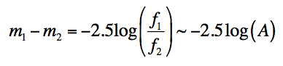(approx. assumes zero blending)

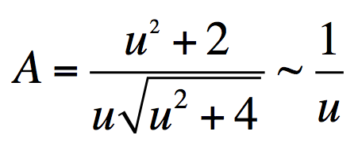(approx assumes u<<1)

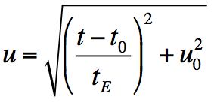

Appendix B: Calculating q

Three Regimes:

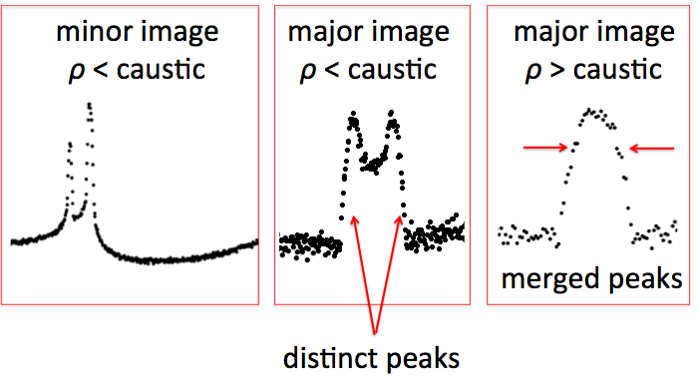
After calculating 𝝆, the procedure differs depending on the regime.

Regimes 1 (minor image) and 2 (major image), both with 𝝆 smaller than the caustic:
- Based on whether this is a major image or a minor image perturbation, decide which planetary caustic structure you should use: diamond (major) or two triangles (minor).
- Given 𝜶 and the features in the light curve, estimate the path of the the source through the caustic(s).
- Estimate the duration of a caustic feature in the light curve.
- Determine 𝝙𝝉 = 𝝙t / t_{E} for that feature.
- Use the diagrams and equations from Han (2006) to match 𝝙𝝉 to a caustic dimension, and solve for q. (Use the limiting approximations.)

Regime 3 where 𝝆 is larger than the caustic:
- Determine the change in magnitude for the caustic, 𝝙mag_{c}.
- Determine A_{p} from 𝝙mag_{c}.
- A_{p} = 2q / 𝝆² (Gould & Gaucherel 1997)

Han 2006 ApJ 638, 1080: Major Image Caustic
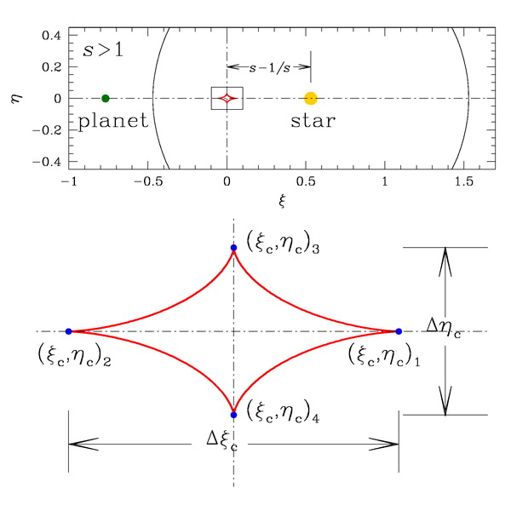

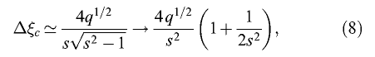
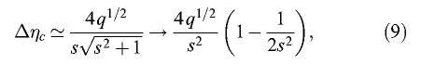

Han 2006 ApJ 638, 1080: Minor Image Caustic
